# **SQL Query Assignment - 1**

1. Find out the PG-13 rated comedy movies. DO NOT use the film_list table.

Query :

select title from film

join film_category on film.film_id=film_category.film_id

join category on film_category.category_id=category.category_id

where name='comedy' and rating='PG-13';

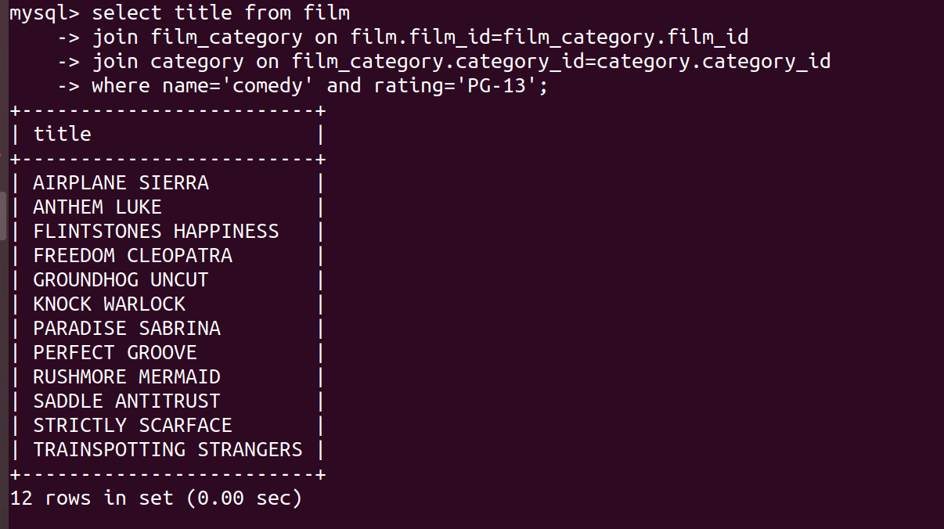

2. Find out the top 3 rented horror movies.

Query:

select title from film f

join inventory i on f.film_id=i.film_id

join rental r on r.inventory_id=i.inventory_id

join film_category fc on fc.film_id=f.film_id

join category c on c.category_id=fc.category_id

where c.name='horror' group by title

order by count(title) desc limit 3;

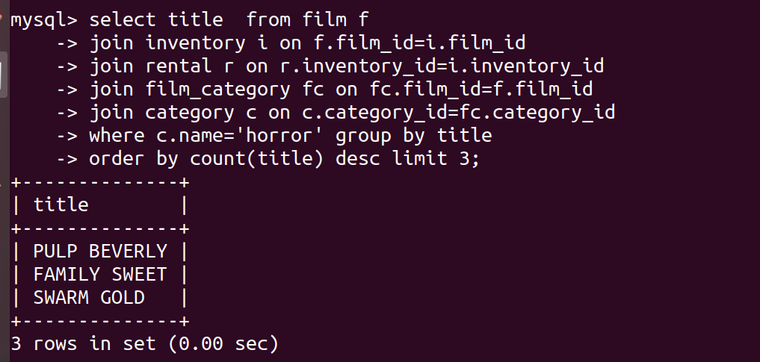

3. Find out the list of customers from India who have rented sports movies.

Query:

select first_name,last_name,country,name from customer c

join rental r on c.customer_id=r.customer_id

join inventory i on i.inventory_id=r.inventory_id

join film_category fc on fc.film_id=i.film_id

join category cat on cat.category_id=fc.category_id

join address a on c.address_id=a.address_id

join city on city.city_id=a.city_id

join country cty on cty.country_id = city.country_id

where country='india' and cat.name='sports';

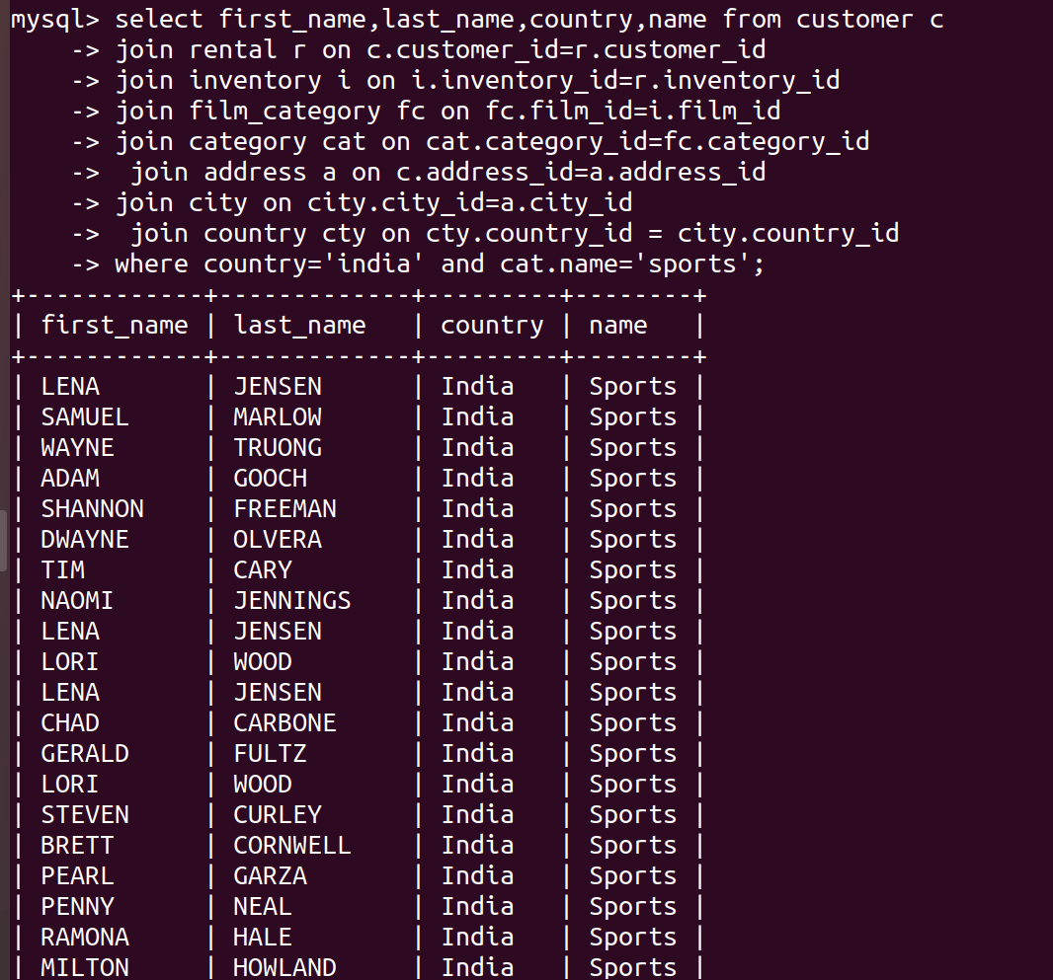

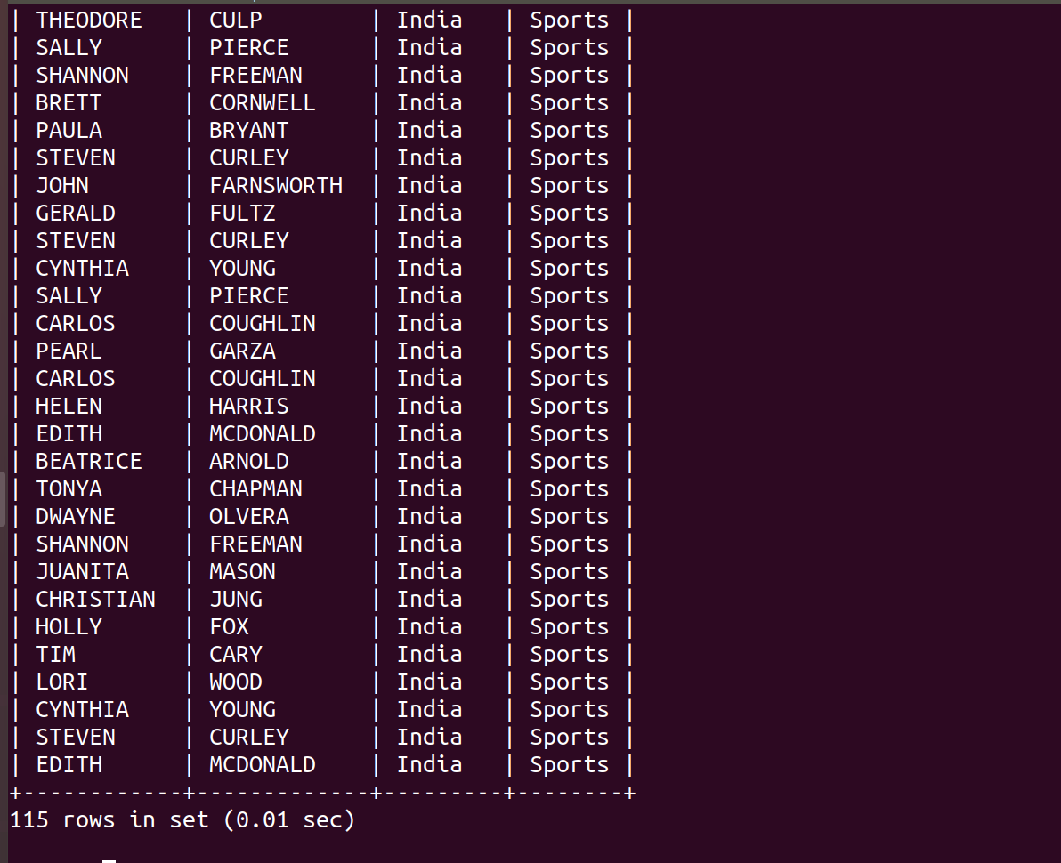

4. Find out the list of customers from Canada who have rented “NICK WAHLBERG” movies.

Query:

select distinct c.first_name,c.last_name,country from customer c

join rental r on c.customer_id=r.customer_id

join inventory i on i.inventory_id=r.inventory_id

join film_actor fa on fa.film_id=i.film_id

join actor on actor.actor_id=fa.actor_id

join address a on c.address_id=a.address_id

join city on city.city_id=a.city_id

join country cty on cty.country_id = city.country_id

where country='canada' and actor.first_name='NICK'

and actor.last_name='WAHLBERG';

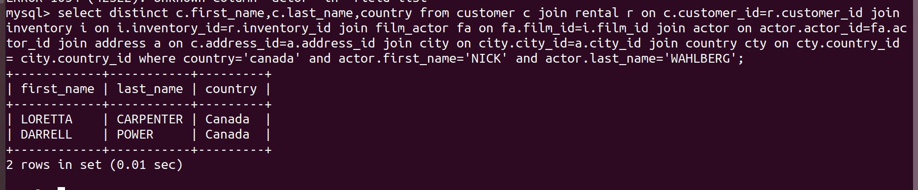

5.Find out the number of movies in which “SEAN WILLIAMS” acted.

Query:

select count(title) as number_of_movies from film f

join film_actor fa on f.film_id=fa.film_id

join actor on actor.actor_id=fa.actor_id

where actor.first_name='SEAN' and actor.last_name='WILLIAMS';

